Assignment 3

Q1) Write an SQL query to insert the above employee records into the EMPLOYEES table.
Ans:
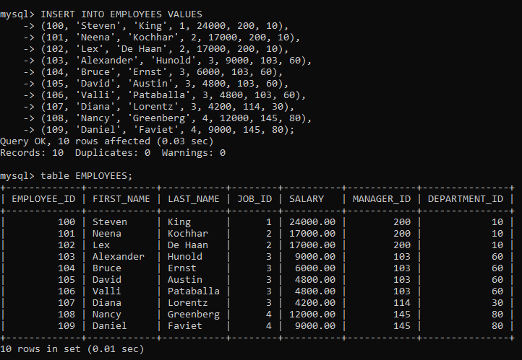
Q2) Write a single SQL INSERT statement to insert at least 3 department records into the DEPARTMENTS table.
Ans:
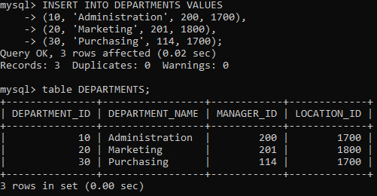
Q3) Write an SQL query to insert one new job record into the JOBS table ensuring duplicate
JOB_ID is not allowed.
Ans:
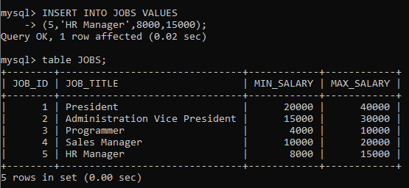

Q4) Write an SQL query to increment the salary of each employee by 10%.
Ans:
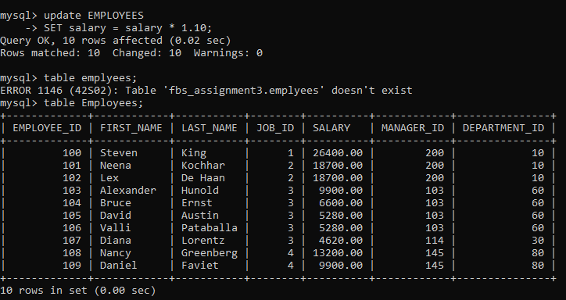

Q5) Write an SQL query to set EMAIL = 'not available' for employees whose department_id is
80 and commission_pct is less than 0.20.
Ans:
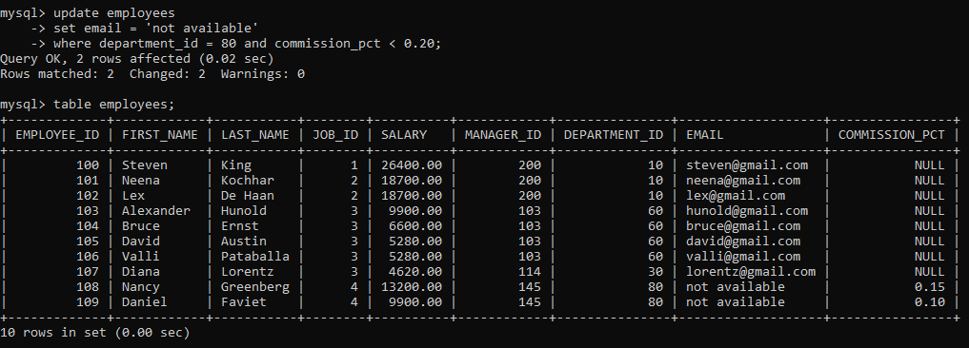
Q6) Write an SQL query to set EMAIL = 'not available' for employees who belong to the
'Purchasing' department.
Ans:
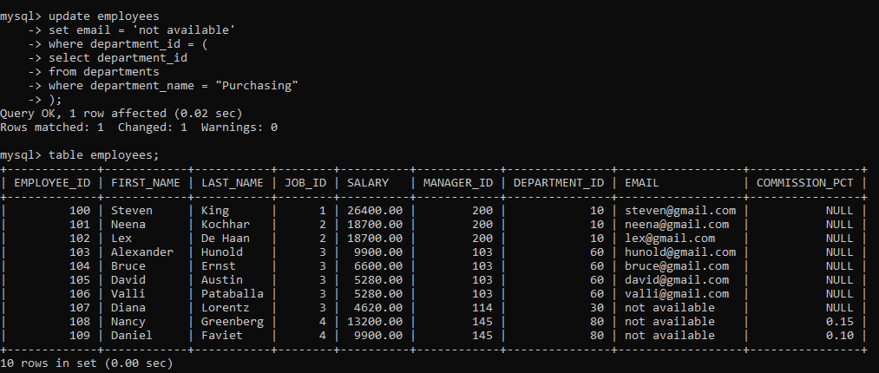

Q7) Write an SQL query to update EMAIL = 'not available' and COMMISSION_PCT = 0.10 for
all employees.
Ans:
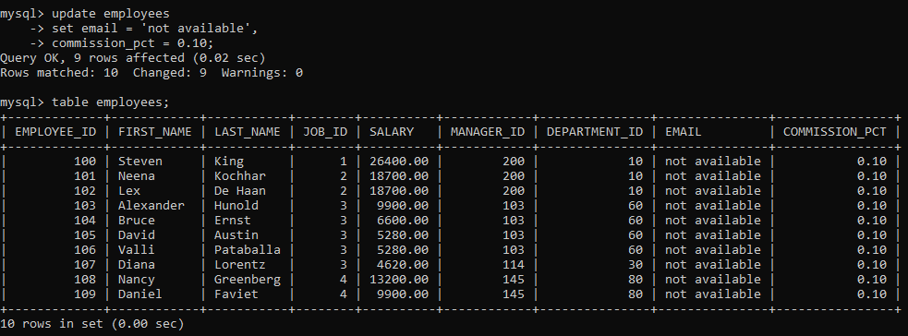

Q8) Write an SQL query to increase salary by 2000 for employees working in department_id =
60.
Ans:
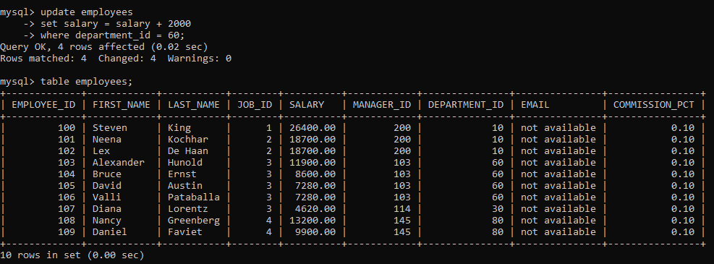

Q9) Write an SQL query to delete employees whose salary is less than 5000.
Ans:
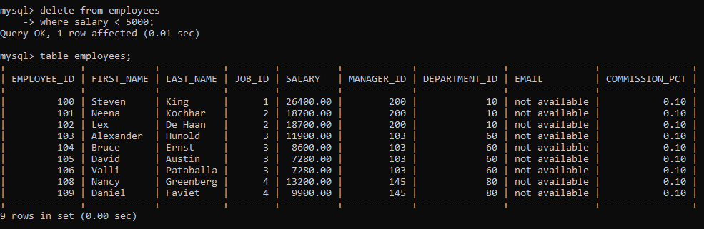

Q10) Write an SQL query to insert one new employee record with your own suitable details (use a new employee_id).
Ans:
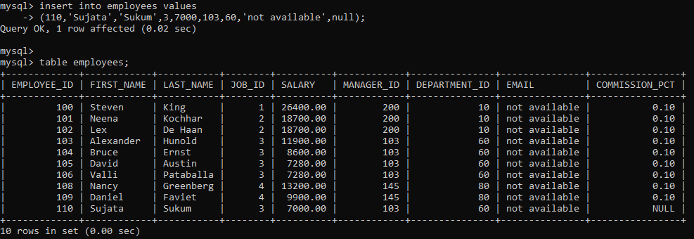

Q11) Write an SQL query to change manager_id to 300 for all employees in department_id = 80.
Ans:
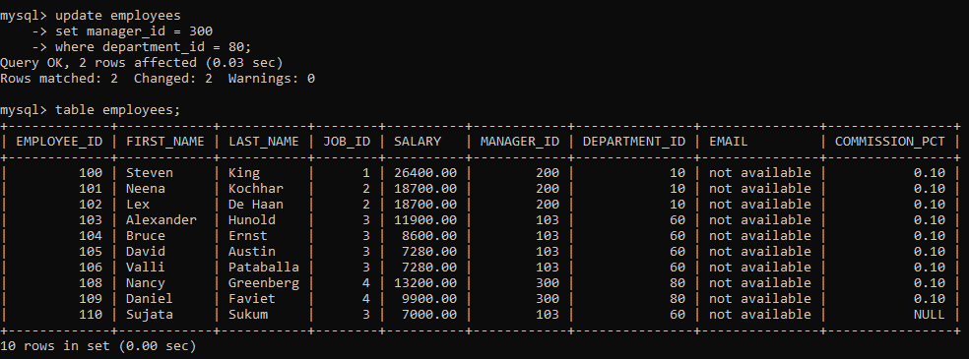

Q12) Write an SQL query to delete the department record where department_id = 20 and observe the error if employees exist in that department.
Ans:
